COS20015 – Fundamentals of Data Management

Learning Summary Report

STUDENT NAME (student id)

Self-Assessment Details

Update header with your name and id. Then delete this box.

The following checklists provide an overview of my self-assessment for this unit.

|  |  |  |  |  |
| --- | --- | --- | --- | --- |
|  | Pass (D) | Credit (C) | Distinction (B) | High Distinction (A) |
| Self-Assessment (please tick) |  |  |  |  |

*Self-assessment Statement*

Tick the box with the grade you are applying for. Then delete this box.

|  |  |
| --- | --- |
|  | Included (please tick) |
| Learning Summary Report |  |
| Test is Complete in Doubtfire |  |
| Task reports that demonstrate coverage of core concepts |  |

*Minimum Pass Checklist*

Check that you have included the minimum required details. Tick these boxes (and ones for higher grades as applies). Then delete this box.

|  |  |
| --- | --- |
|  | Included (please tick) |
| Progress on Credit Tasks |  |
| All Pass Tasks signed off in Doubtfire |  |

*Minimum Credit Checklist, in addition to Pass Checklist*

|  |  |
| --- | --- |
|  | Included (please tick) |
| Credit and Pass Tasks done, and Progress on Distinction Tasks. |  |
| Custom data store meets Distinction criteria |  |
| Design report with suitable illustrations of data store |  |

*Minimum Distinction Checklist, in addition to Credit Checklist*

|  |  |
| --- | --- |
|  | Included (please tick) |
| Research report, and associated pieces |  |
| Custom project meets HD requirements |  |

*Minimum High Distinction Checklist, in addition to Distinction Checklist*

# Declaration

I declare that this portfolio is my individual work. I have not copied from any other student’s work or from any other source except where due acknowledgment is made explicitly in the text, nor has any part of this submission been written for me by another person.

Signature:

# Introduction

This report summarises what I have learnt in COS20015 Fundamentals of Data Management. It includes a self-assessment against the criteria described in the unit outline, a justification of the pieces included, details of the coverage of the unit’s intended learning outcomes, and a reflection on my learning.

# Overview of Pieces Included

Add a list of all of the pieces that you are including. Write a sentence to briefly describe each. (then delete this box)

This section outlines the pieces that I have included in my portfolio…

1. **Test**: my attempt at the test conducted in the unit.
2. **Text processing**: this task…
3. …

# Coverage of the Intended Learning Outcomes

This section outlines how the pieces I have included demonstrate the depth of my understanding in relation to each of the unit’s intended learning outcomes.

## ILO 1: Data Management Theory

Appreciate set theory, relational algebra, ternary logic, and algorithmic complexity in the context of data management.

The following pieces demonstrate my ability in relation to this ILO:

For each ILO, describe the work you have included in your portfolio that demonstrates your ability in relation to the required outcomes. Then delete this box.

* Test 1: question … demonstrates …
* …

## ILO 2: Storing Data

Use techniques, tools and methods to sort, search and transform data stored in a variety of data formats.

…

## ILO 3: Data Representation and Access

Explain the role of data types, data representation, indexing and schemas in managing data, and use methods to validate that data matches an expected schema.

…

## ILO 4: Data Retrieval and Performance

Use appropriate methods to efficiently store, insert and retrieve data appreciating the underlying trade offs between different strategies.

…

## ILO 5: Concurrency Considerations

Appreciate issues related to concurrency in data management and describe basic strategies for addressing these issues.

…

# Reflection

## The most important things I learnt:

Reflect on your learning and discuss these areas. Read the suggestions in [ ] for each question. Write your reflections then delete the text in the [ ] and delete this box.

[ Think about topics covered, but also other general things you may have learnt. Think about what you have learnt in this subject, and reflect on what you think were key learning points, or incidents. Did you learn what you wanted/expected to learn? ]

## The things that helped me most were:

[ List and explain ]

## I found the following topics particularly challenging:

[ List and explain – if none explain why ]

## I found the following topics particularly interesting:

[ List and explain – remove if none ]

## I feel I learnt these topics, concepts, and/or tools really well:

[ List and explain – if none explain why, refer to your pieces for evidence to support your claims ]

## I still need to work on the following areas:

[ List and explain – if none explain why, refer to your pieces ]

## My progress in this unit was …:

[ Include a screenshot of your **progress graph** from **DoubtFire**, and comment on what happened from your perspective… what does the graph say about how you approached the unit? (Login to Doubtfire to get your graph <https://doubtfire.ict.swin.edu.au>)]

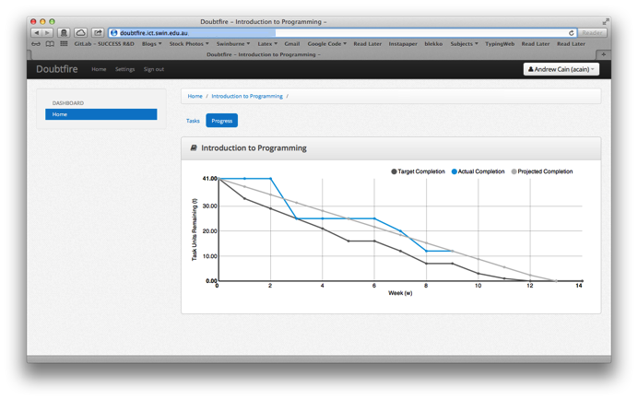

## This unit will help me in the future:

[ How will the things you learnt relate to the rest of your studies, and career. What have you learnt that will be valuable for you in the future? ]

## If I did this unit again I would do the following things differently:

[ List and explain, how will you approach learning in the future? What things worked well, but what could you change to make sure you did better next time?]

## Other…:

[ Add any other reflections you think help you demonstrate your learning ]